1. 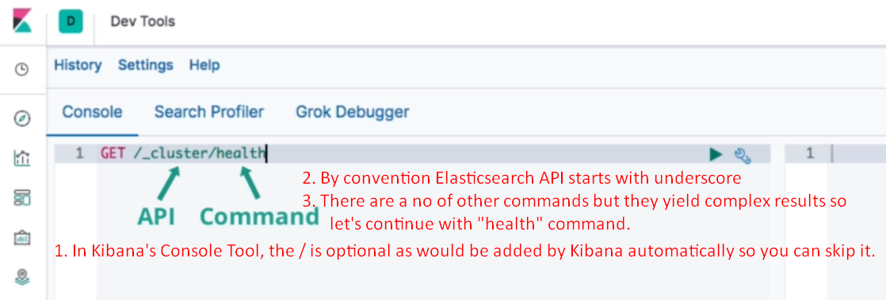
2. 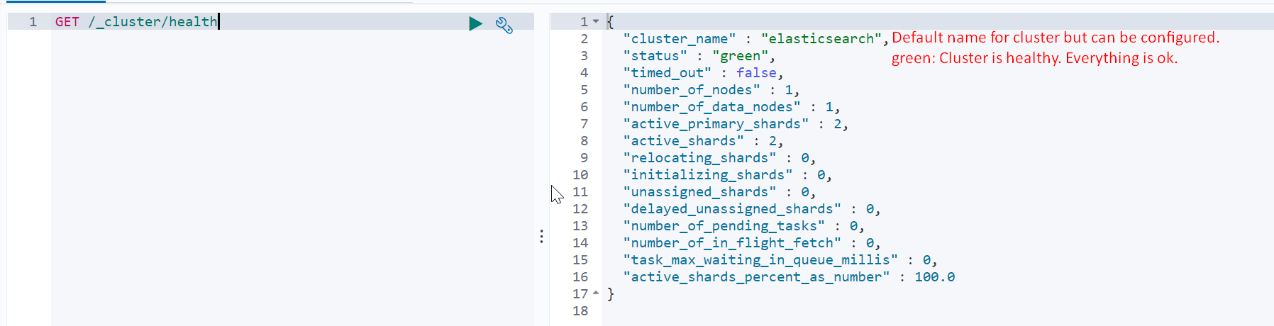
3. **Node Info**:  
   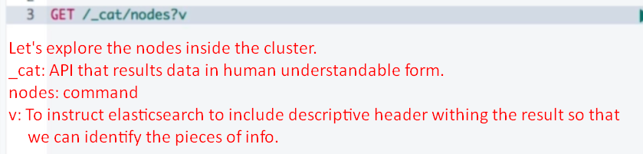
4. 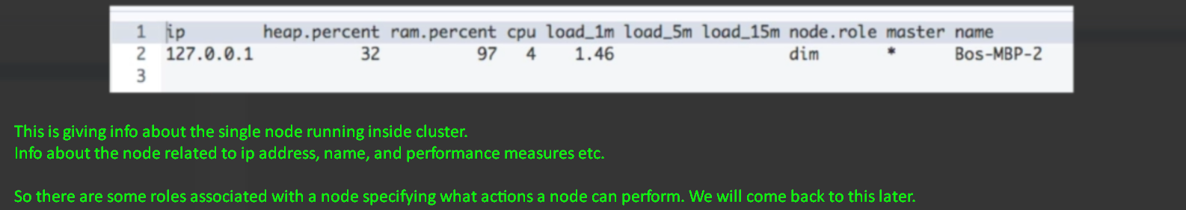
5. There is an API _nodes which returns detailed data in JSON format that maybe useful in debugging.
6. 
7. 
8. 
9. 
10. 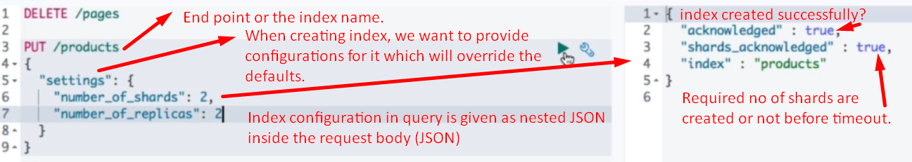
11. 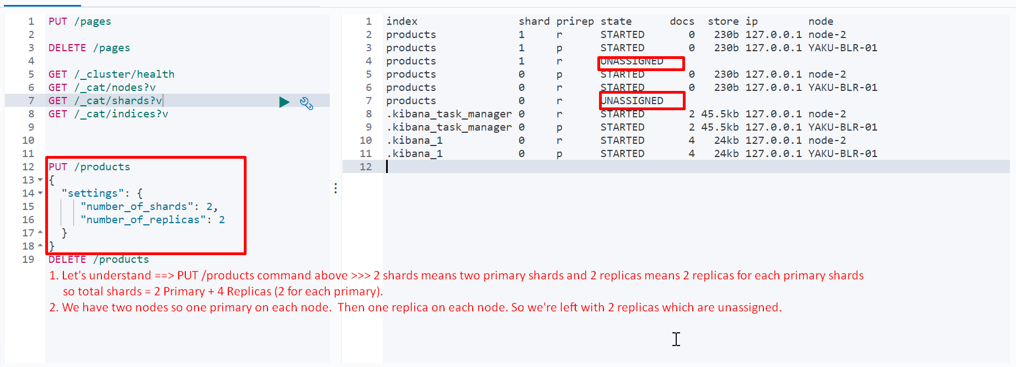
12. 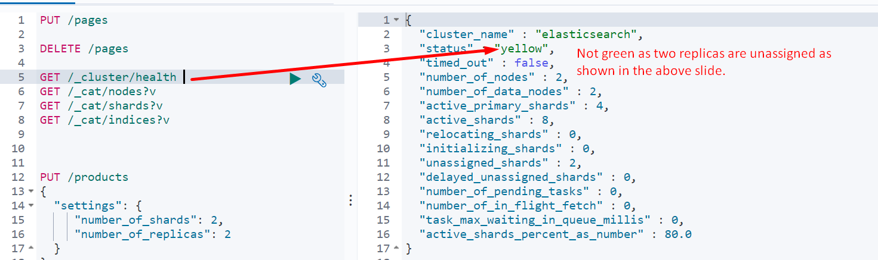
13. Start From section 3 lecture 2